* Full name: Iván Kaleb Ramírez Torres
* NAO ID: 3357
* Date: September 30, 2025
* Name of the pathway in which you are enrolled: Bécalos Techno Ready
* Title of the Challenge: **Challenge 3 – Server and Database Commands**

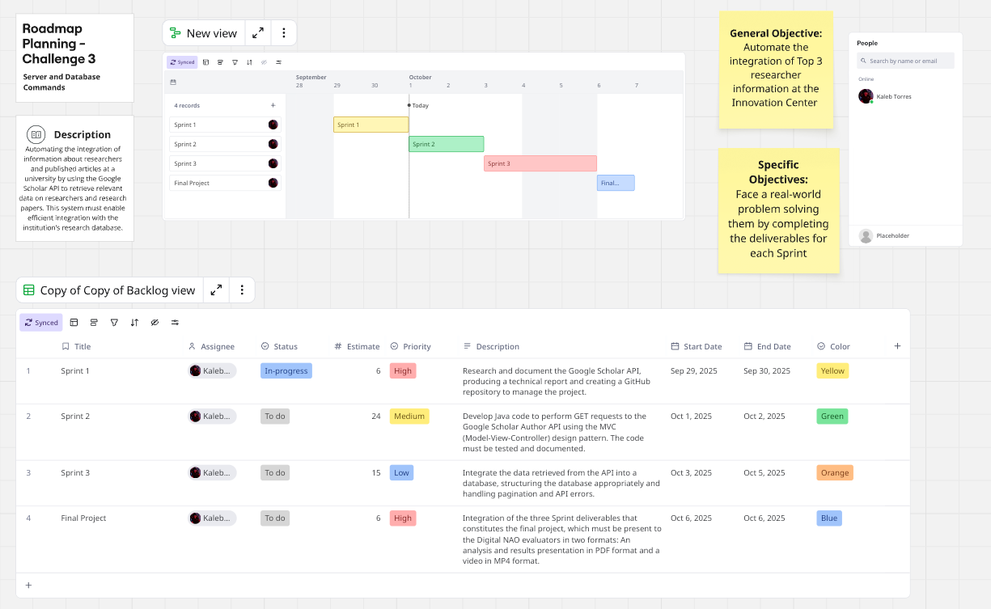 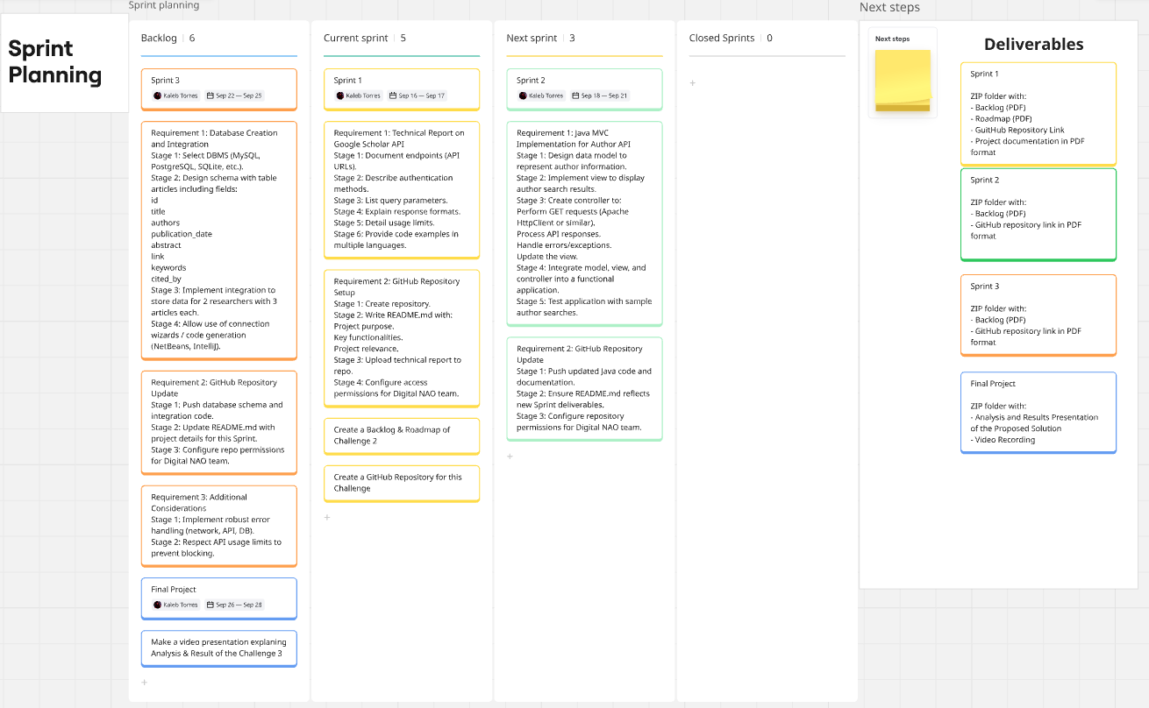

Para una mejor visualización, visitar:

<https://miro.com/app/board/uXjVJA0X69I=/>